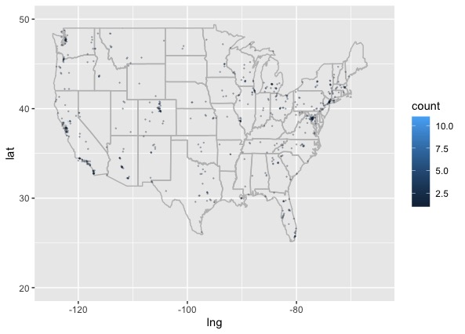

British Columbia: 29

Ontario: 40

29

33

6

2

Connecticut: 11

Washington DC: 33

Delaware: 1

Massachusetts: 22

Maryland: 24

New Hampshire: 4

New Jersey: 12

Rhode Island: 2

Vermont: 6

29

42

6

2

12

6

18

20

6

4

25

44

7

9

2

10

5

24

3

11

14

4

2

7

6

16

9

24

9

15

39

50

1224

1

4

Alaska: 7

Hawaii: 18